There are two types of Forms

1. Static Form
2. Dynamic Form

* The form page whose content is fixed is called static form page.

Ex:- .html files generate static form pages.

* The form page that is generated as output given by servlet or jsp comp having dynamic content / varying content is called dynamic form page.

Example:

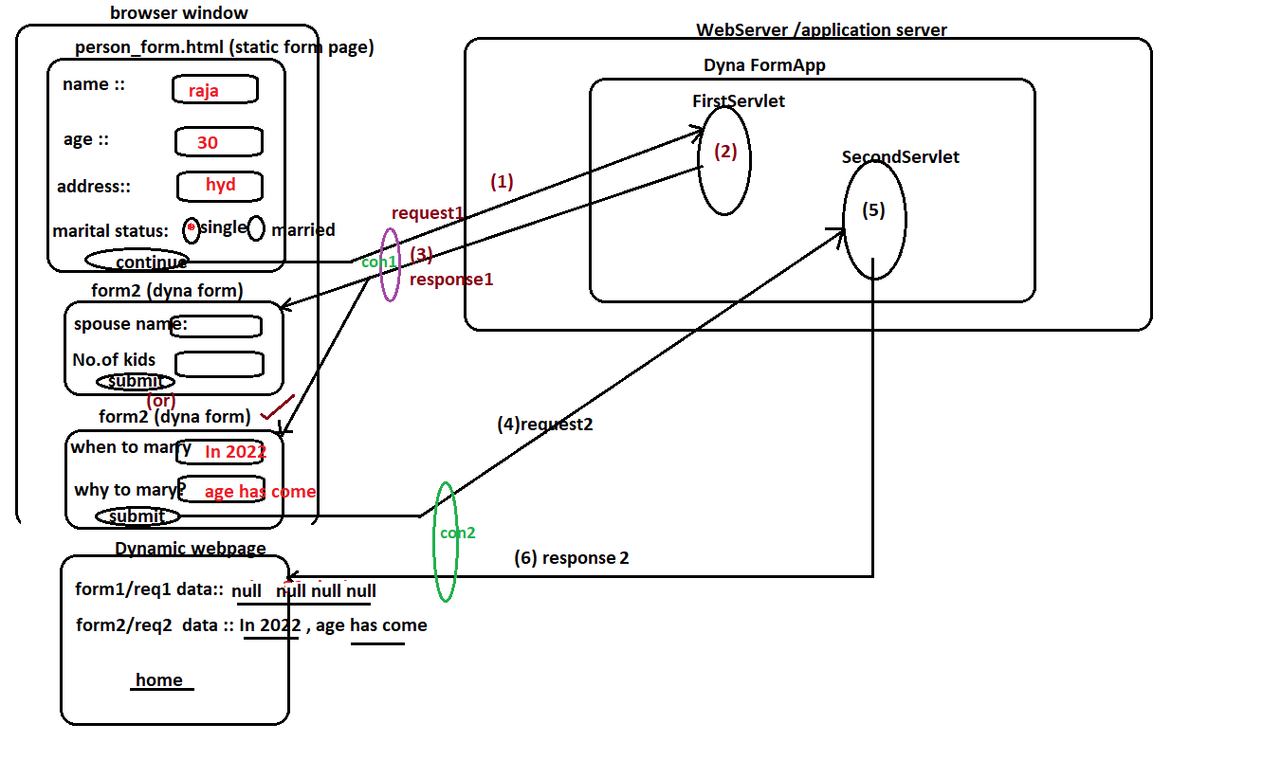

Project Directory Structure:

===================

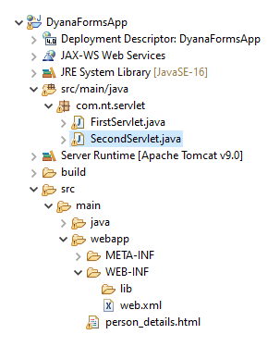

PersonalDetails.html

===============

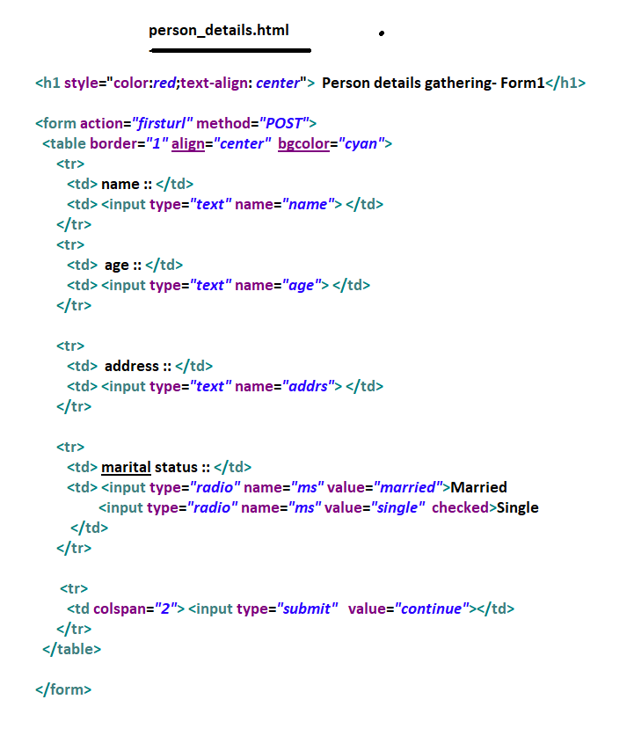

FirstServlet.java

===========

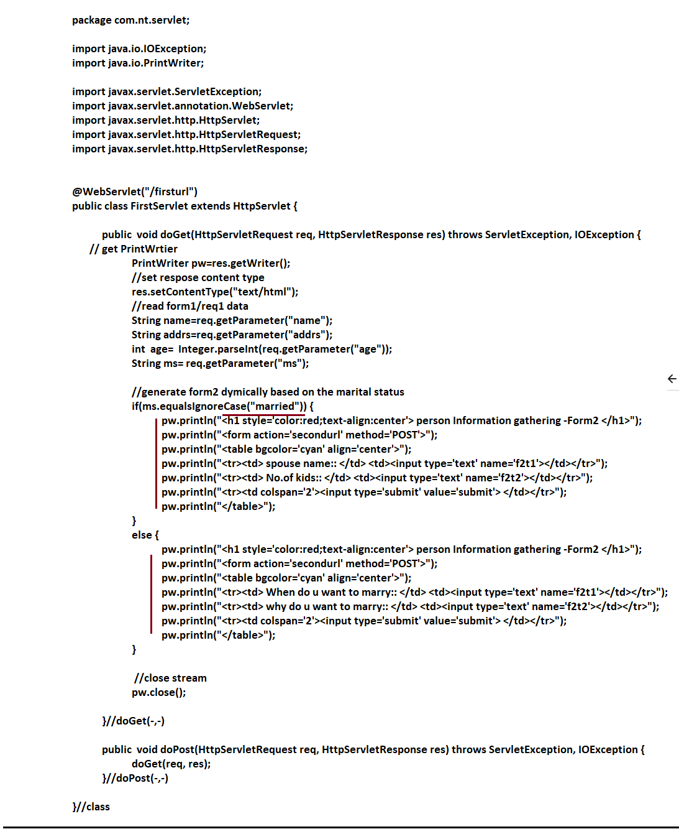

SecondServlet.java

==============

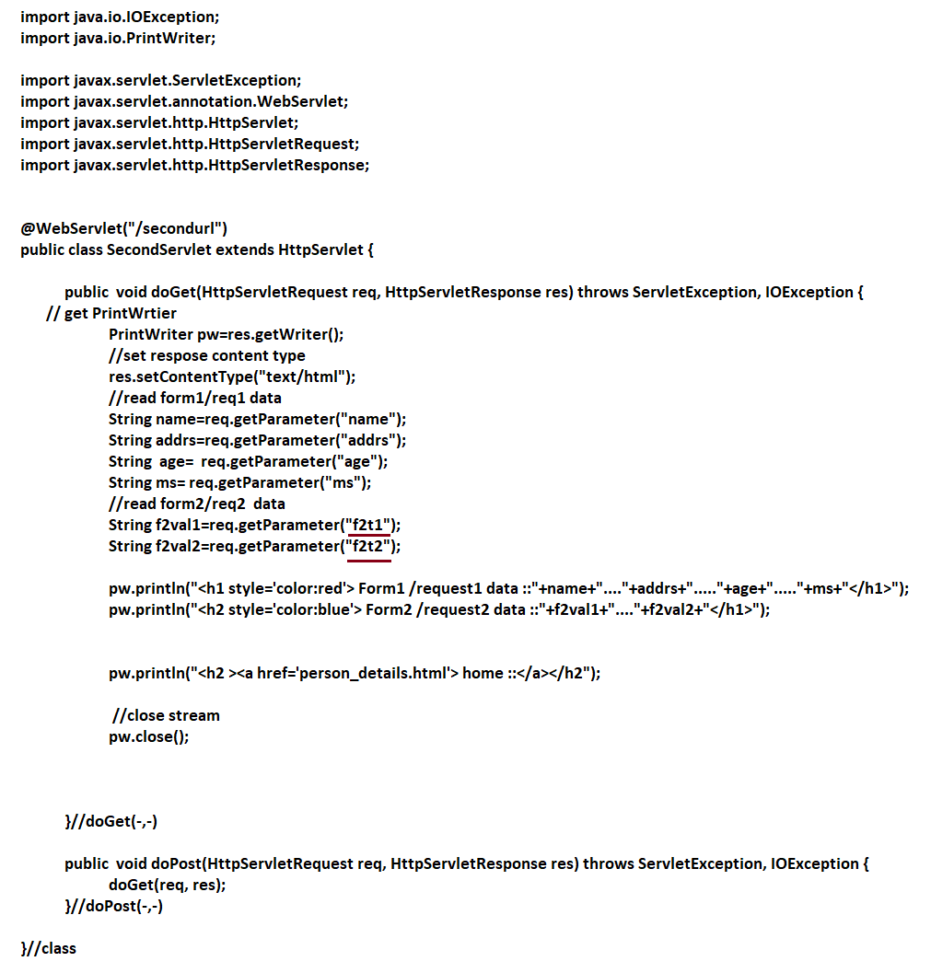

Output:

=======

